**Milestone 2: Design document**

**Due date** : May 25th, 2020, 09:00

**Introduction**

The main objective of our visualisation project is to provide information to people moving to a Foreign country, either as short-term travellers, or to relocate in the longer run for instance for professional reasons. We focus on daily activities in different countries, and more specifically we consider two key aspects: how much time is dedicated to these activities on a daily basis, and at what time main activities are mostly conducted.

To answer these questions, we rely on two separate csv files. The first one considers the average daily time spent for each of the 56 activities considered. It covers 14 European countries, and also allows for a finer representation by gender. It is this file which allows us to say that French citizens spend most of their daily time eating, while German are mostly working and studying.

The second file considers the same set of countries but adopts a more temporal approach. For different periods of the day (by slices of 10 minutes), it indicates what percentage of the population is currently busy running a given activity. It is the one file to use to discover that German eat at 6pm, while Spanish will rather dine at 9pm.

We hope to provide responses to these questions by the way of a dashboard offering both intuitive visualisations and a rich representation of the data.

# Our three design ideas

While discussing our (initially 15) design ideas, we found out they could fall into 3 main design ideas, with variants in the representation that are discussed below.

## First design : Europe map, overview

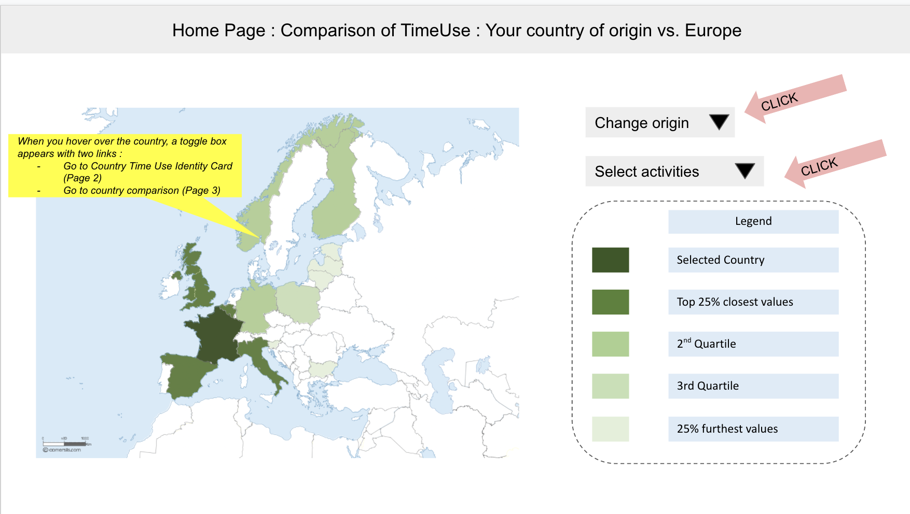

*Figure 1. Europe map*

On this Europe map is displayed how much time people spend on a specific activity daily, per country. The representation as a map *presents* a quite natural overview, where countries are easy to *locate*. The metric used for the calculations is the timeuse per activity. The color will represent the percentage of difference between the selected country and all the European countries in the dataset. The stronger the colour, the closer to the selected country. This would allow the user to have a quick view over the different habits in Europe and be able to easily interact with the map to swiftly get the info they need.

Possible interactions include :

* Selecting which activity Europeans spend time (choose among a list)
* *Hovering* over the map provides tooltip for each country, with the name of the country (so as to *browse* as the user is not necessarily very knowledgeable in geography) and detailed figures about time spent in hours and minutes, more accurate than just the color.
* *Filter* by gender (or total of both)
* *Selecting* a country to “visit” by clicking on it, which brings to a view dedicated to this country. We like the idea of going to the country, as it emphases the travel idea.

*Select* activity:

The user can choose an activity among the list, so that he/she can discover, *generate* and/or verify *hypotheses,* and let some freedom to serendipity. Still, as the original list is quite long, it is sorted upfront with the most common first.

It is possible in this version of the design to filter to choose to display data for one gender or for both.

This design is very nice as an overview of Europe. It suits well as a starting point for a journey.

## Second design : country identity card

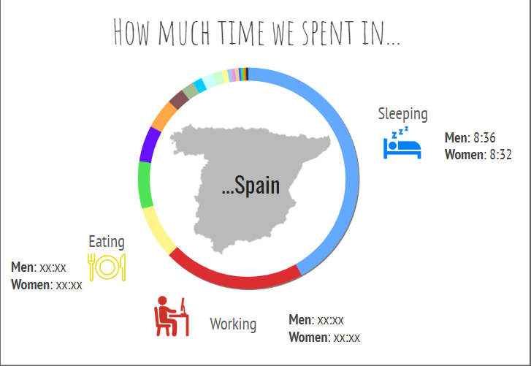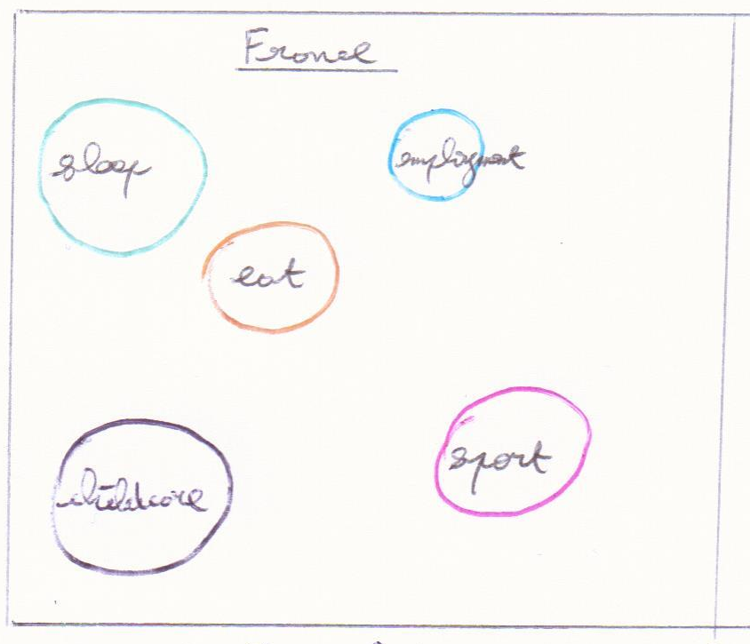

*Figure 2a. Donut Figure 2b. Bubbles*

The second design is about presenting how people spend their time in a specific country.

The specific country can be selected among the list of the European countries (*filter*).

We thought about several design approaches :

* A **donut** or  **pie chart** *presents* a nice *summary* of the repartition of all activities contribution of the time spent in total (the donut with the advantage that a map of the country can be put in the middle for prominent identification of country)
* **Bubble view** may be better suited for *exploring*, playing around within all activities

One design we like is to display each activity as a bubble, which size represents the time spend. The bubbles location does not really matter. Next to each bubble may be a visual indication of what the activity is (e.g. a bed for sleep, a plate for eating…). By default, the top 10 activities in this country are displayed.

We also thought about rectangles next to each other for a better scale readability, but adjusting the pictures when displaying more or less activities may become tricky: would be suitable for presenting when already decided which activities for each country, less suitable for exploring.

Interaction :

* activities : one can choose which ones to add or remove from a list (*filter*).
* gender distinction : allow comparison between men and women
* by time of the day

Additional information : gender comparison

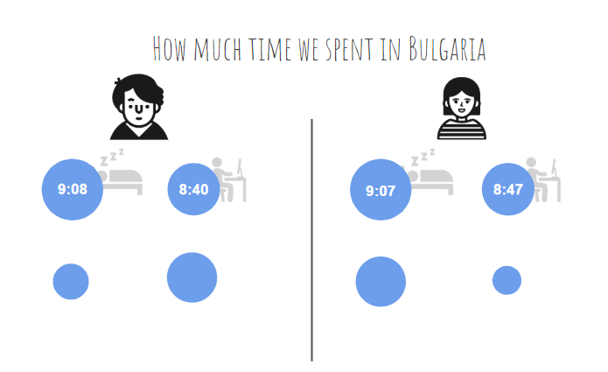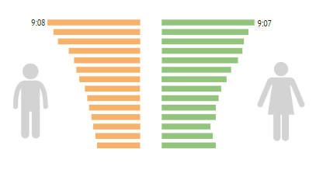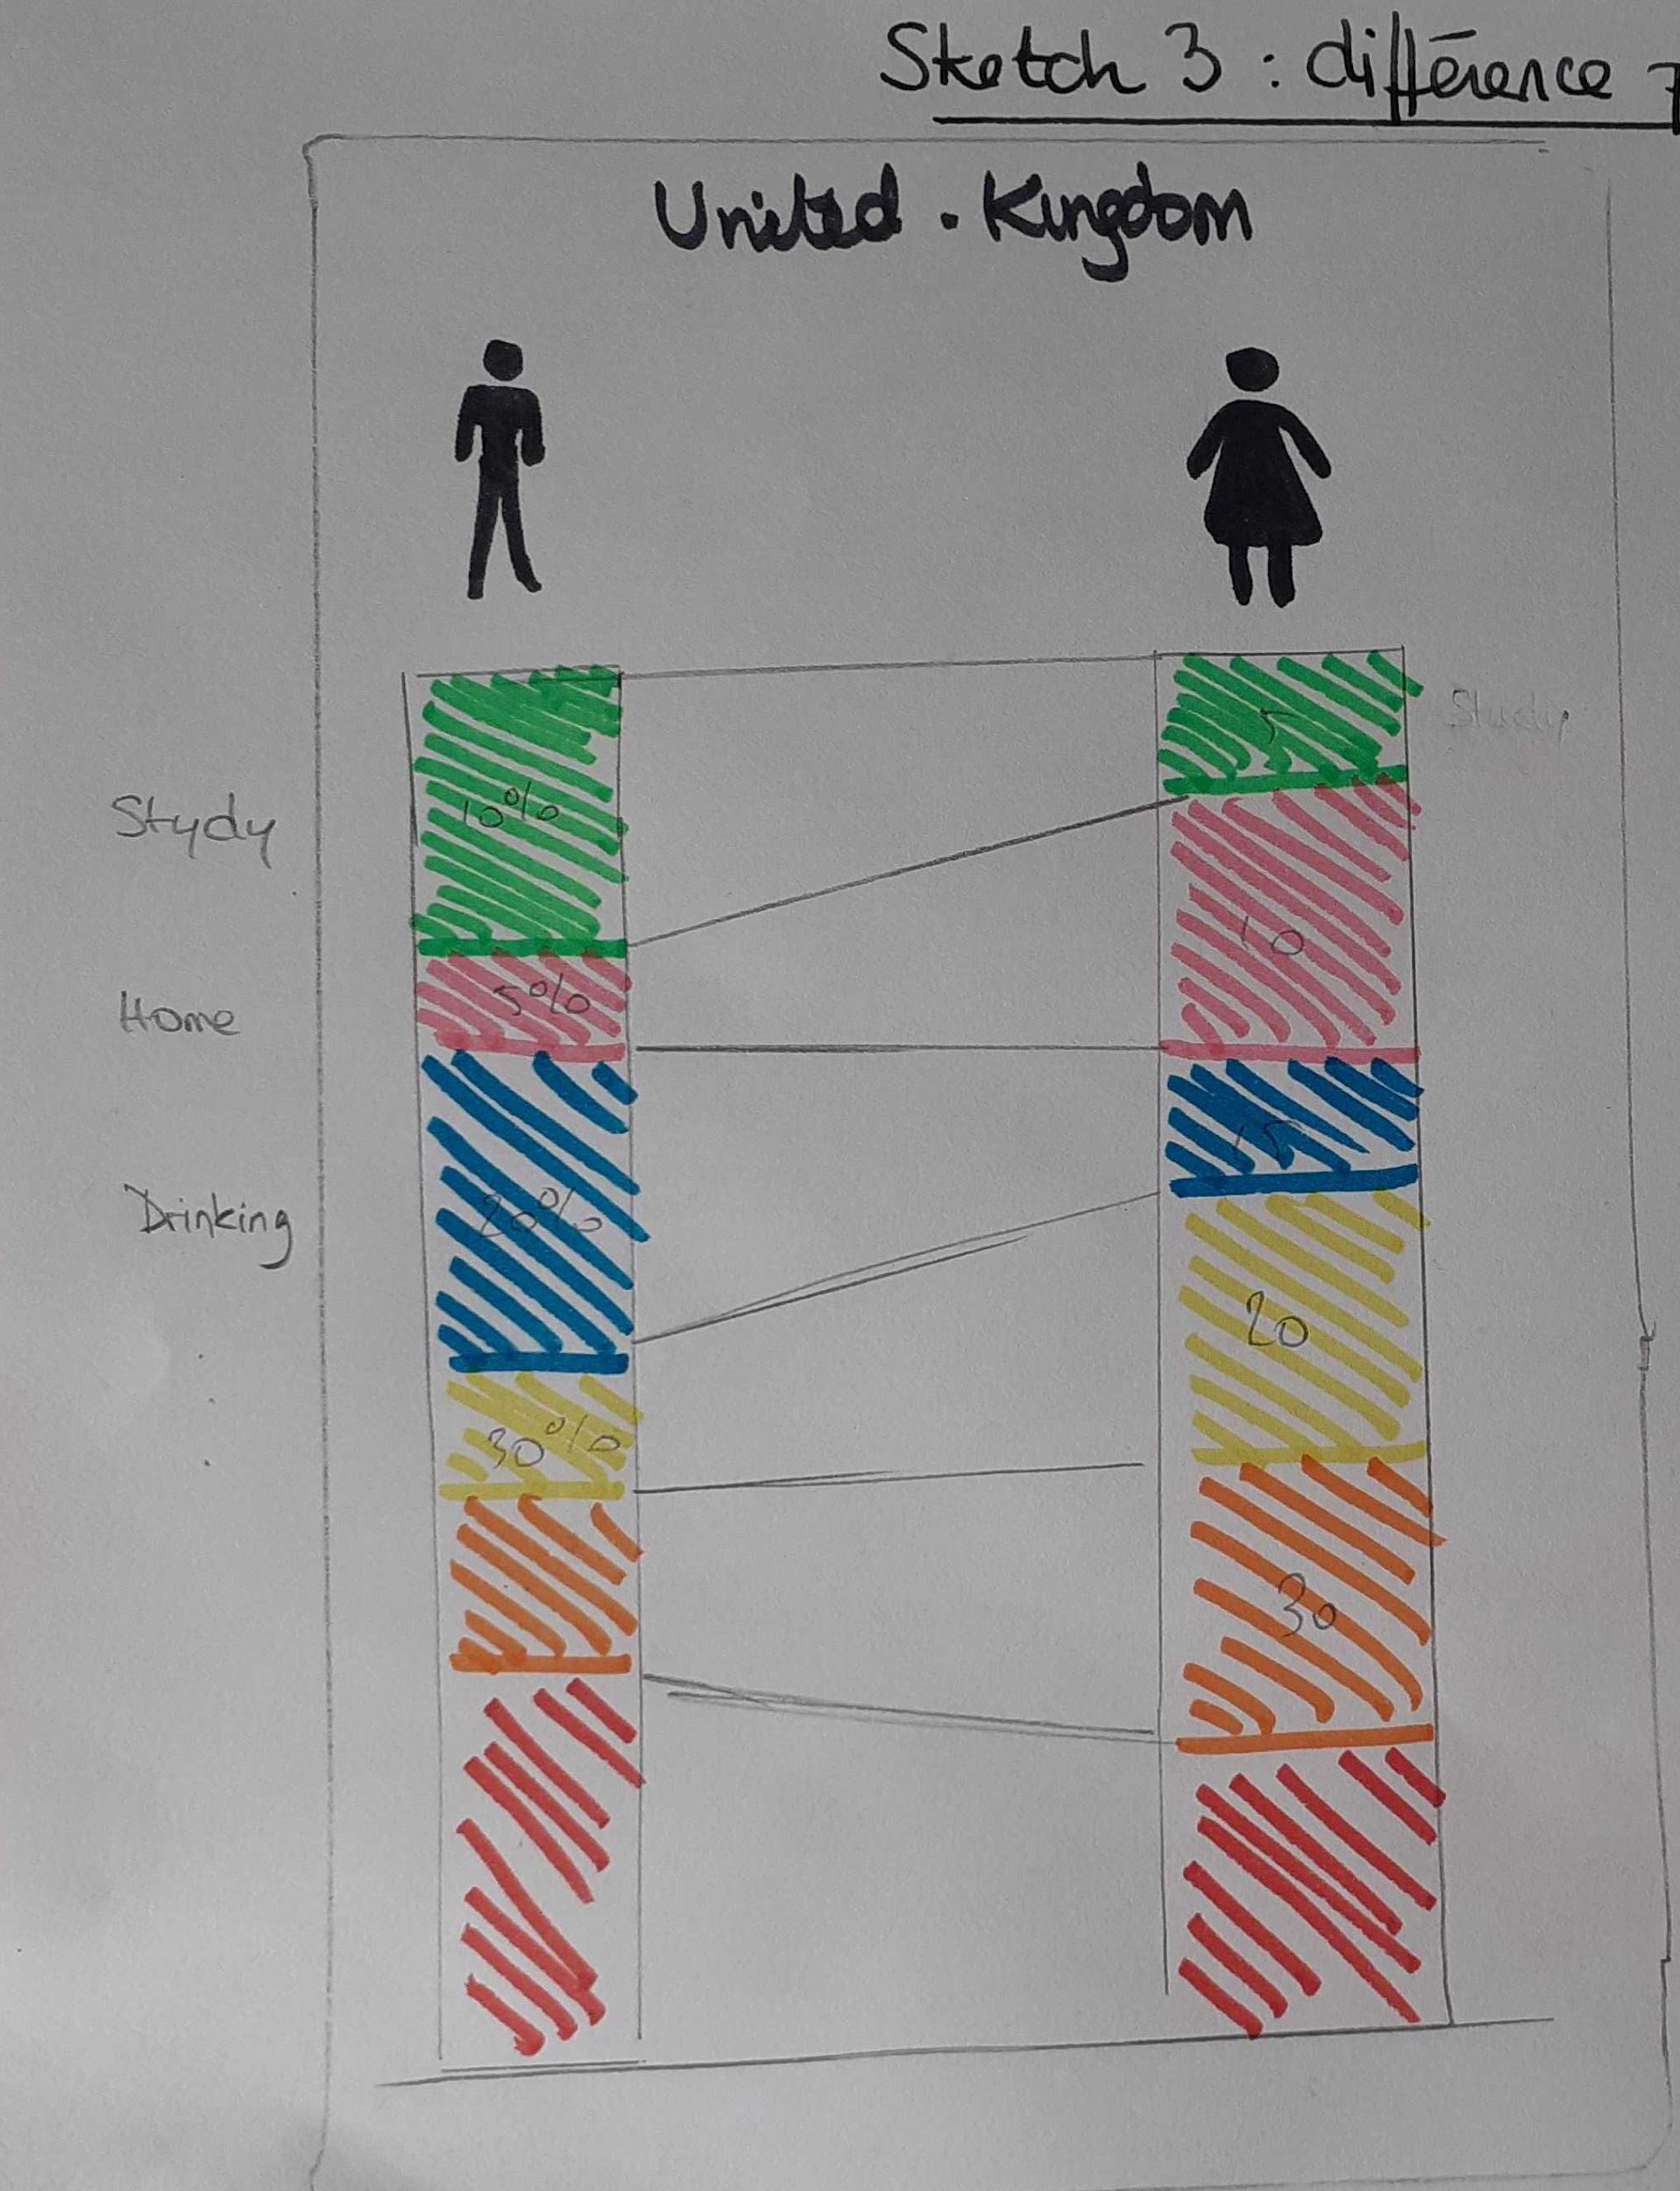

*Figure 2c. Duplicated bubbles Figure 2d. Pyramid Fig 2e. Parallel coordinates*

The gender comparison for a specific country applies to the list of activities chosen from the list.

This gender comparison can be displayed as:

* duplicated bubble view duplicated, just to get an idea if there is a difference
* via a single bubble view, with blue and red dots in each bubble (the number of dots indicating the proportion, with the same total number of red and blues dots)
* via a pyramid.
* via **parallel coordinates**, which we prefer as the focus here is clearly on the differences between the two columns (genders) for any set of activities.

Additional information : time schedule

Note that the dataset available with schedule information provides information per country and per gender for each 10min slot of a 24h day, with activities already aggregated into 7 categories (the list is visible in fig. 2g).

Time organization of the day

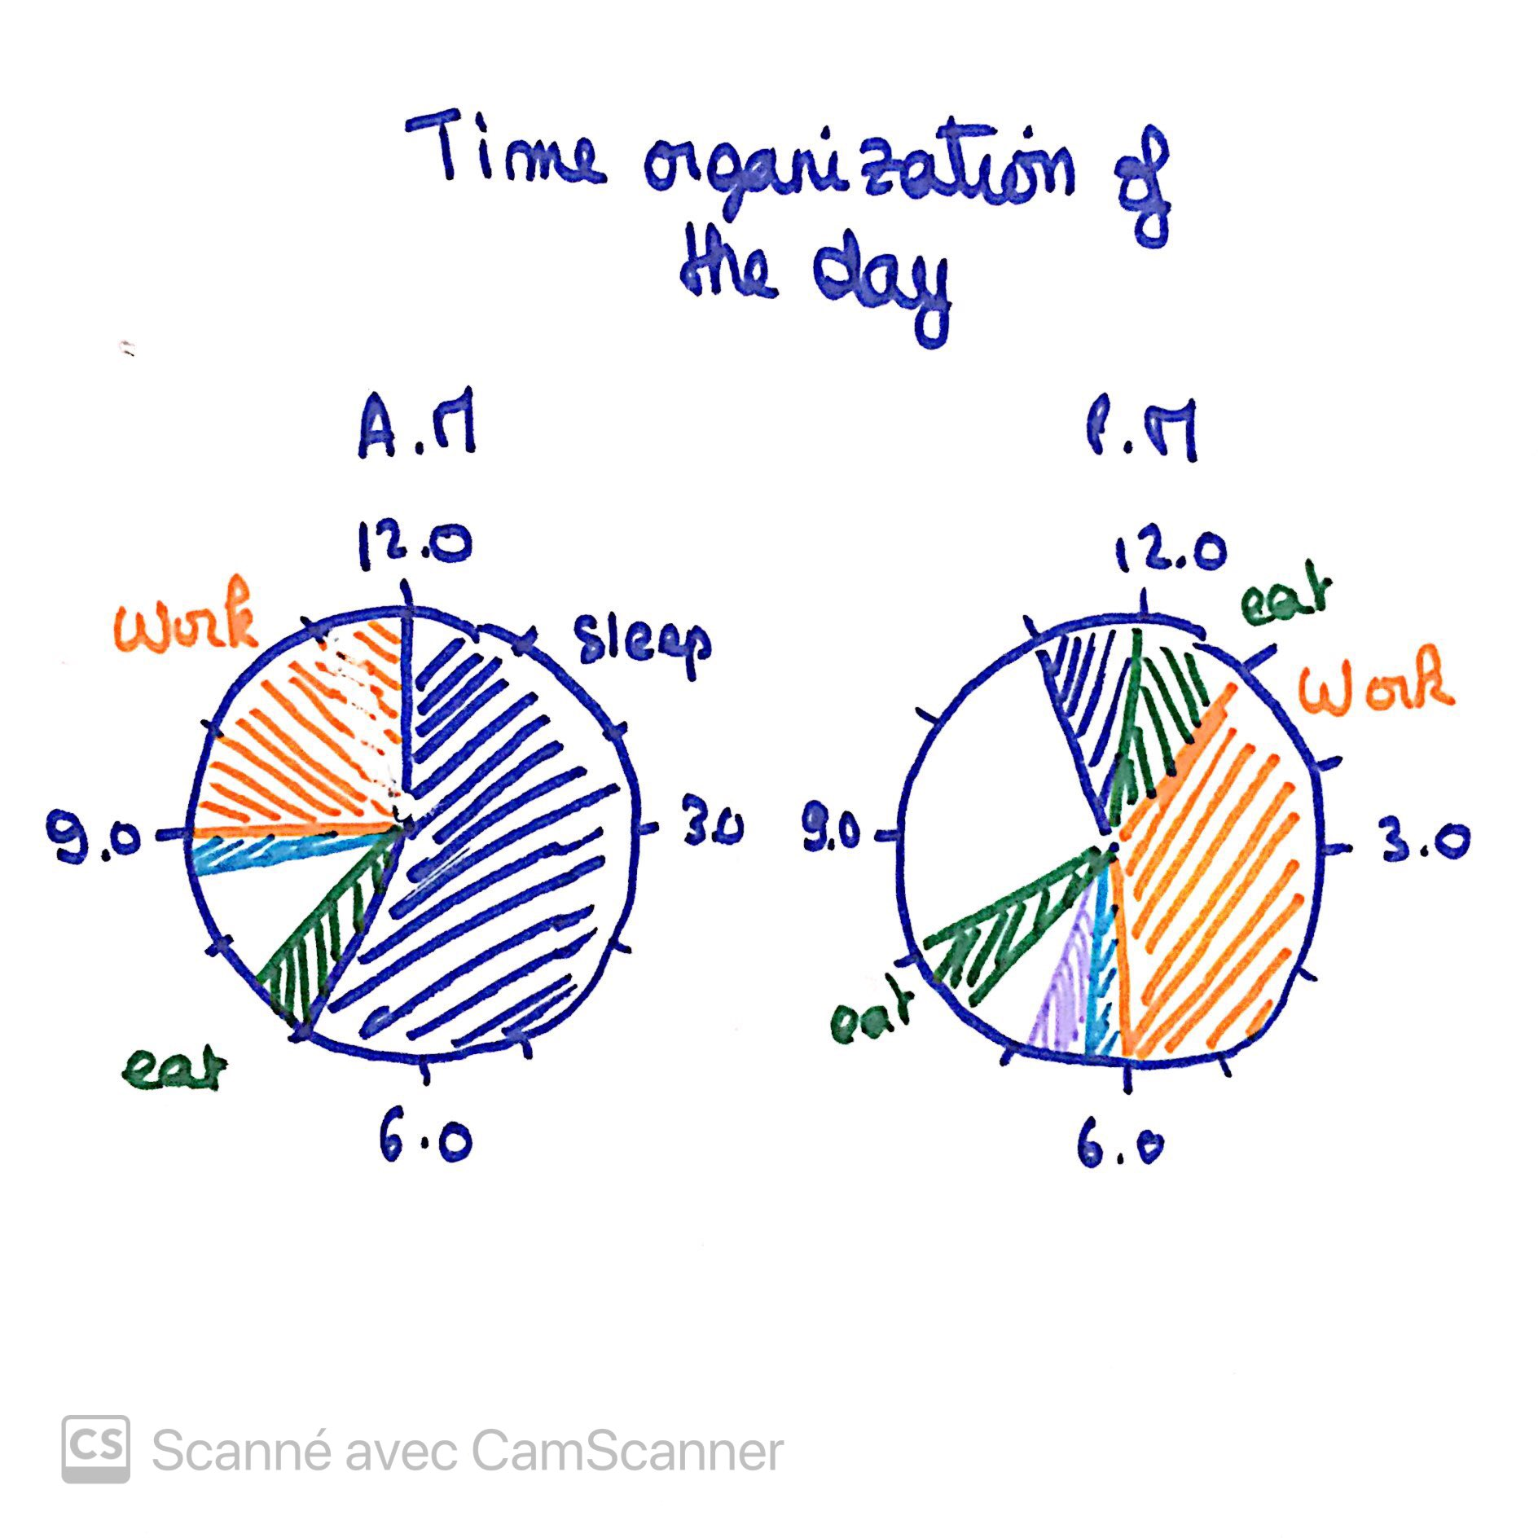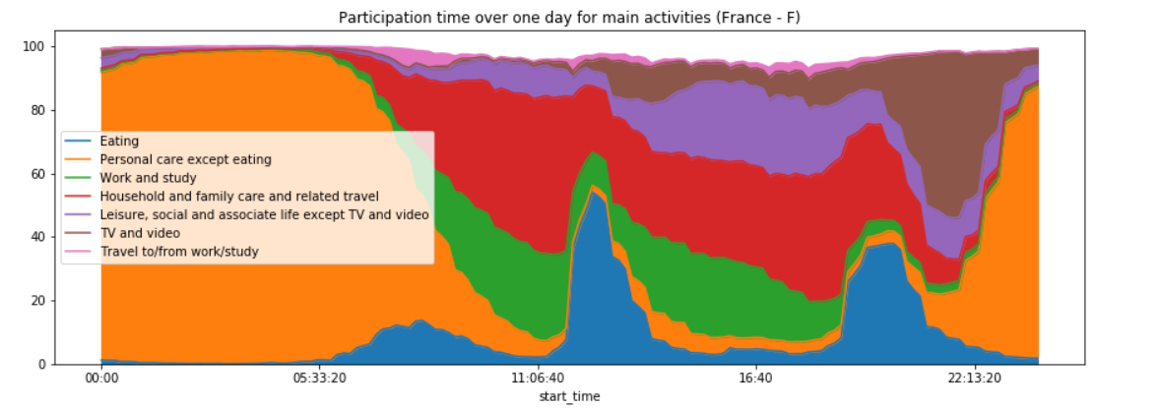

*Figure 2f. Morning/afternoon pies Figure 2g. Stacked area schedule*

The user may also be interested in when do people perform the activity during the day.

We thought about several alternatives:

* simply duplicating the overview pie charts for e.g. morning and afternoon
* making the bubble view evolve with time : bubbles grow or decrease automatically as a clock on the top of the drawing
* stacked area of the time series.

The fixed pies have the drawback that you can’t tell whether e.g. people eat earlier or later depending on whether in the North or South of Europe, we miss the schedule.

The bubble view over time seems nice at first as it comes naturally as an evolution of the bubble static view, it supports many activities simultaneously, but it has the drawback that after the first feeling of how nice, you realize you have to go round the clock each time…

**Stacked area** has the advantage of the overview over the day. It can become clumsy when too many activities are displayed simultaneously, but as the activities available in the schedule dataset are only 7, it is still manageable, and more compact representation than small multiples.

## Third design : countries comparison

The 3rd design allow the user to compare 2 countries. We chose to compare two countries at a time, which fits nicely with the idea of comparing a destination with your own country (if the user wants to compare two potential destinations instead, nothing prevents it).

We had several ideas in order to compare time spent and schedules :

* focus on differences : calculate and represent the difference in time spent for each activity between the two countries
* focus on actual values : show the actual value of time spent for each activity for the 2 countries
* focus on schedule : have a representation of the time at which the main activities are carried out

*1st idea : focus on differences*

Here are some propositions of representations for the differences view :

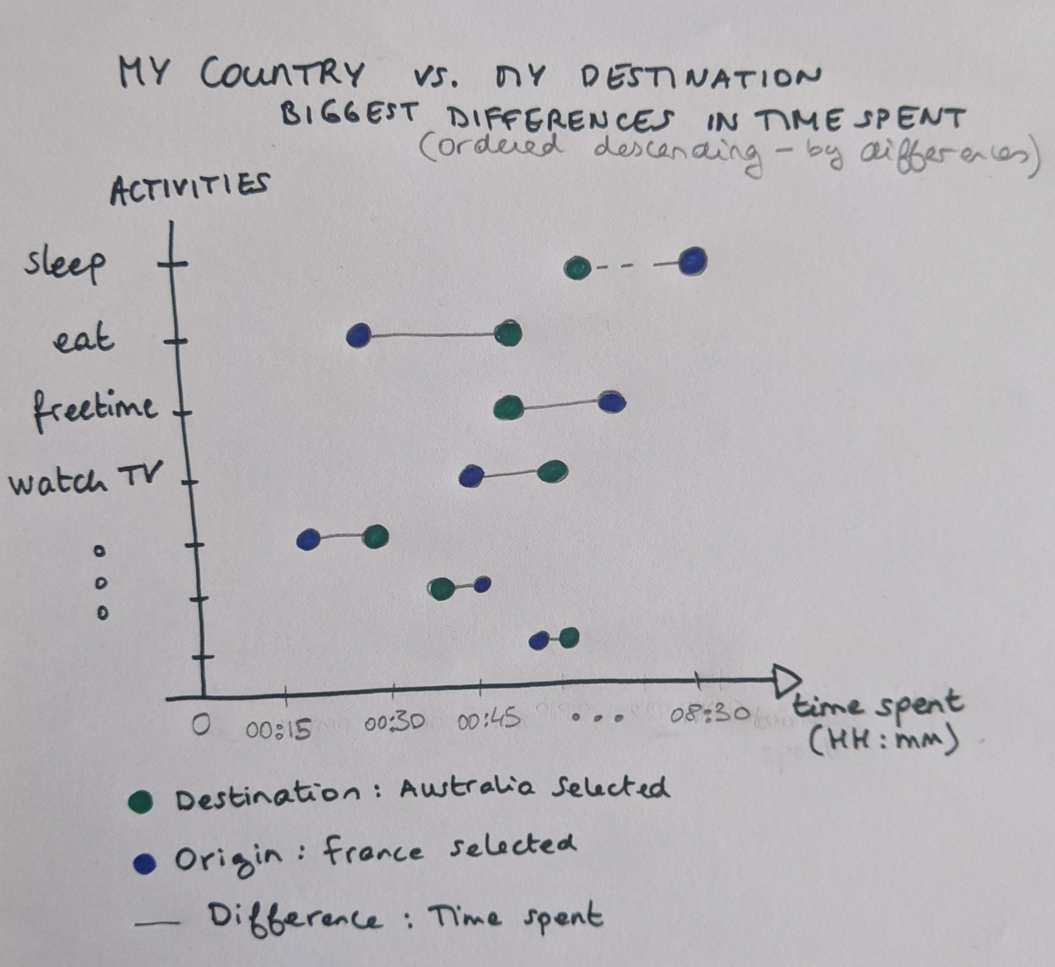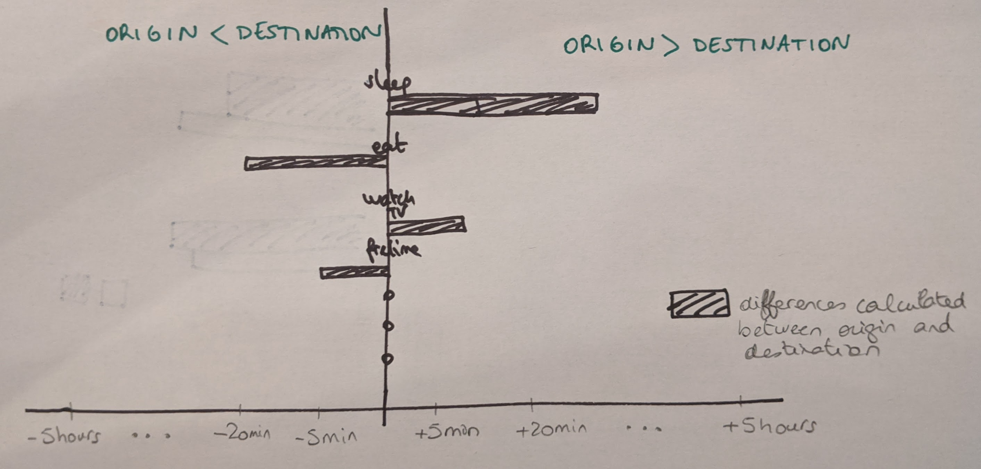

These views are based on the 1st data file.

The first proposition gives a direct idea of the differences in time spent for each activity, which can be very interesting for the user, who wants to compare countries. By default, the 10 biggest differences are displayed, so that the user knows which activities are likely to be changed in terms of habit on the next trip or journey.

We chose to represent here the differences in terms of time spent, so that the user has a direct reading of the differences that may exist between his country and his destination.

The true values in past time are also displayed, and follow the horizontal axis. Activities are sorted in order of difference (descending).

The second proposal shows the differences (positive and negative) between countries of origin and destination, by activity. In the same way as the first one, the activities are sorted by differences. This graph has the disadvantage of being more difficult to read than the first one, as the user has to understand in which direction the difference is calculated.

*2nd idea : focus on values of time spent*

Here are some propositions of representations for the time spent view :

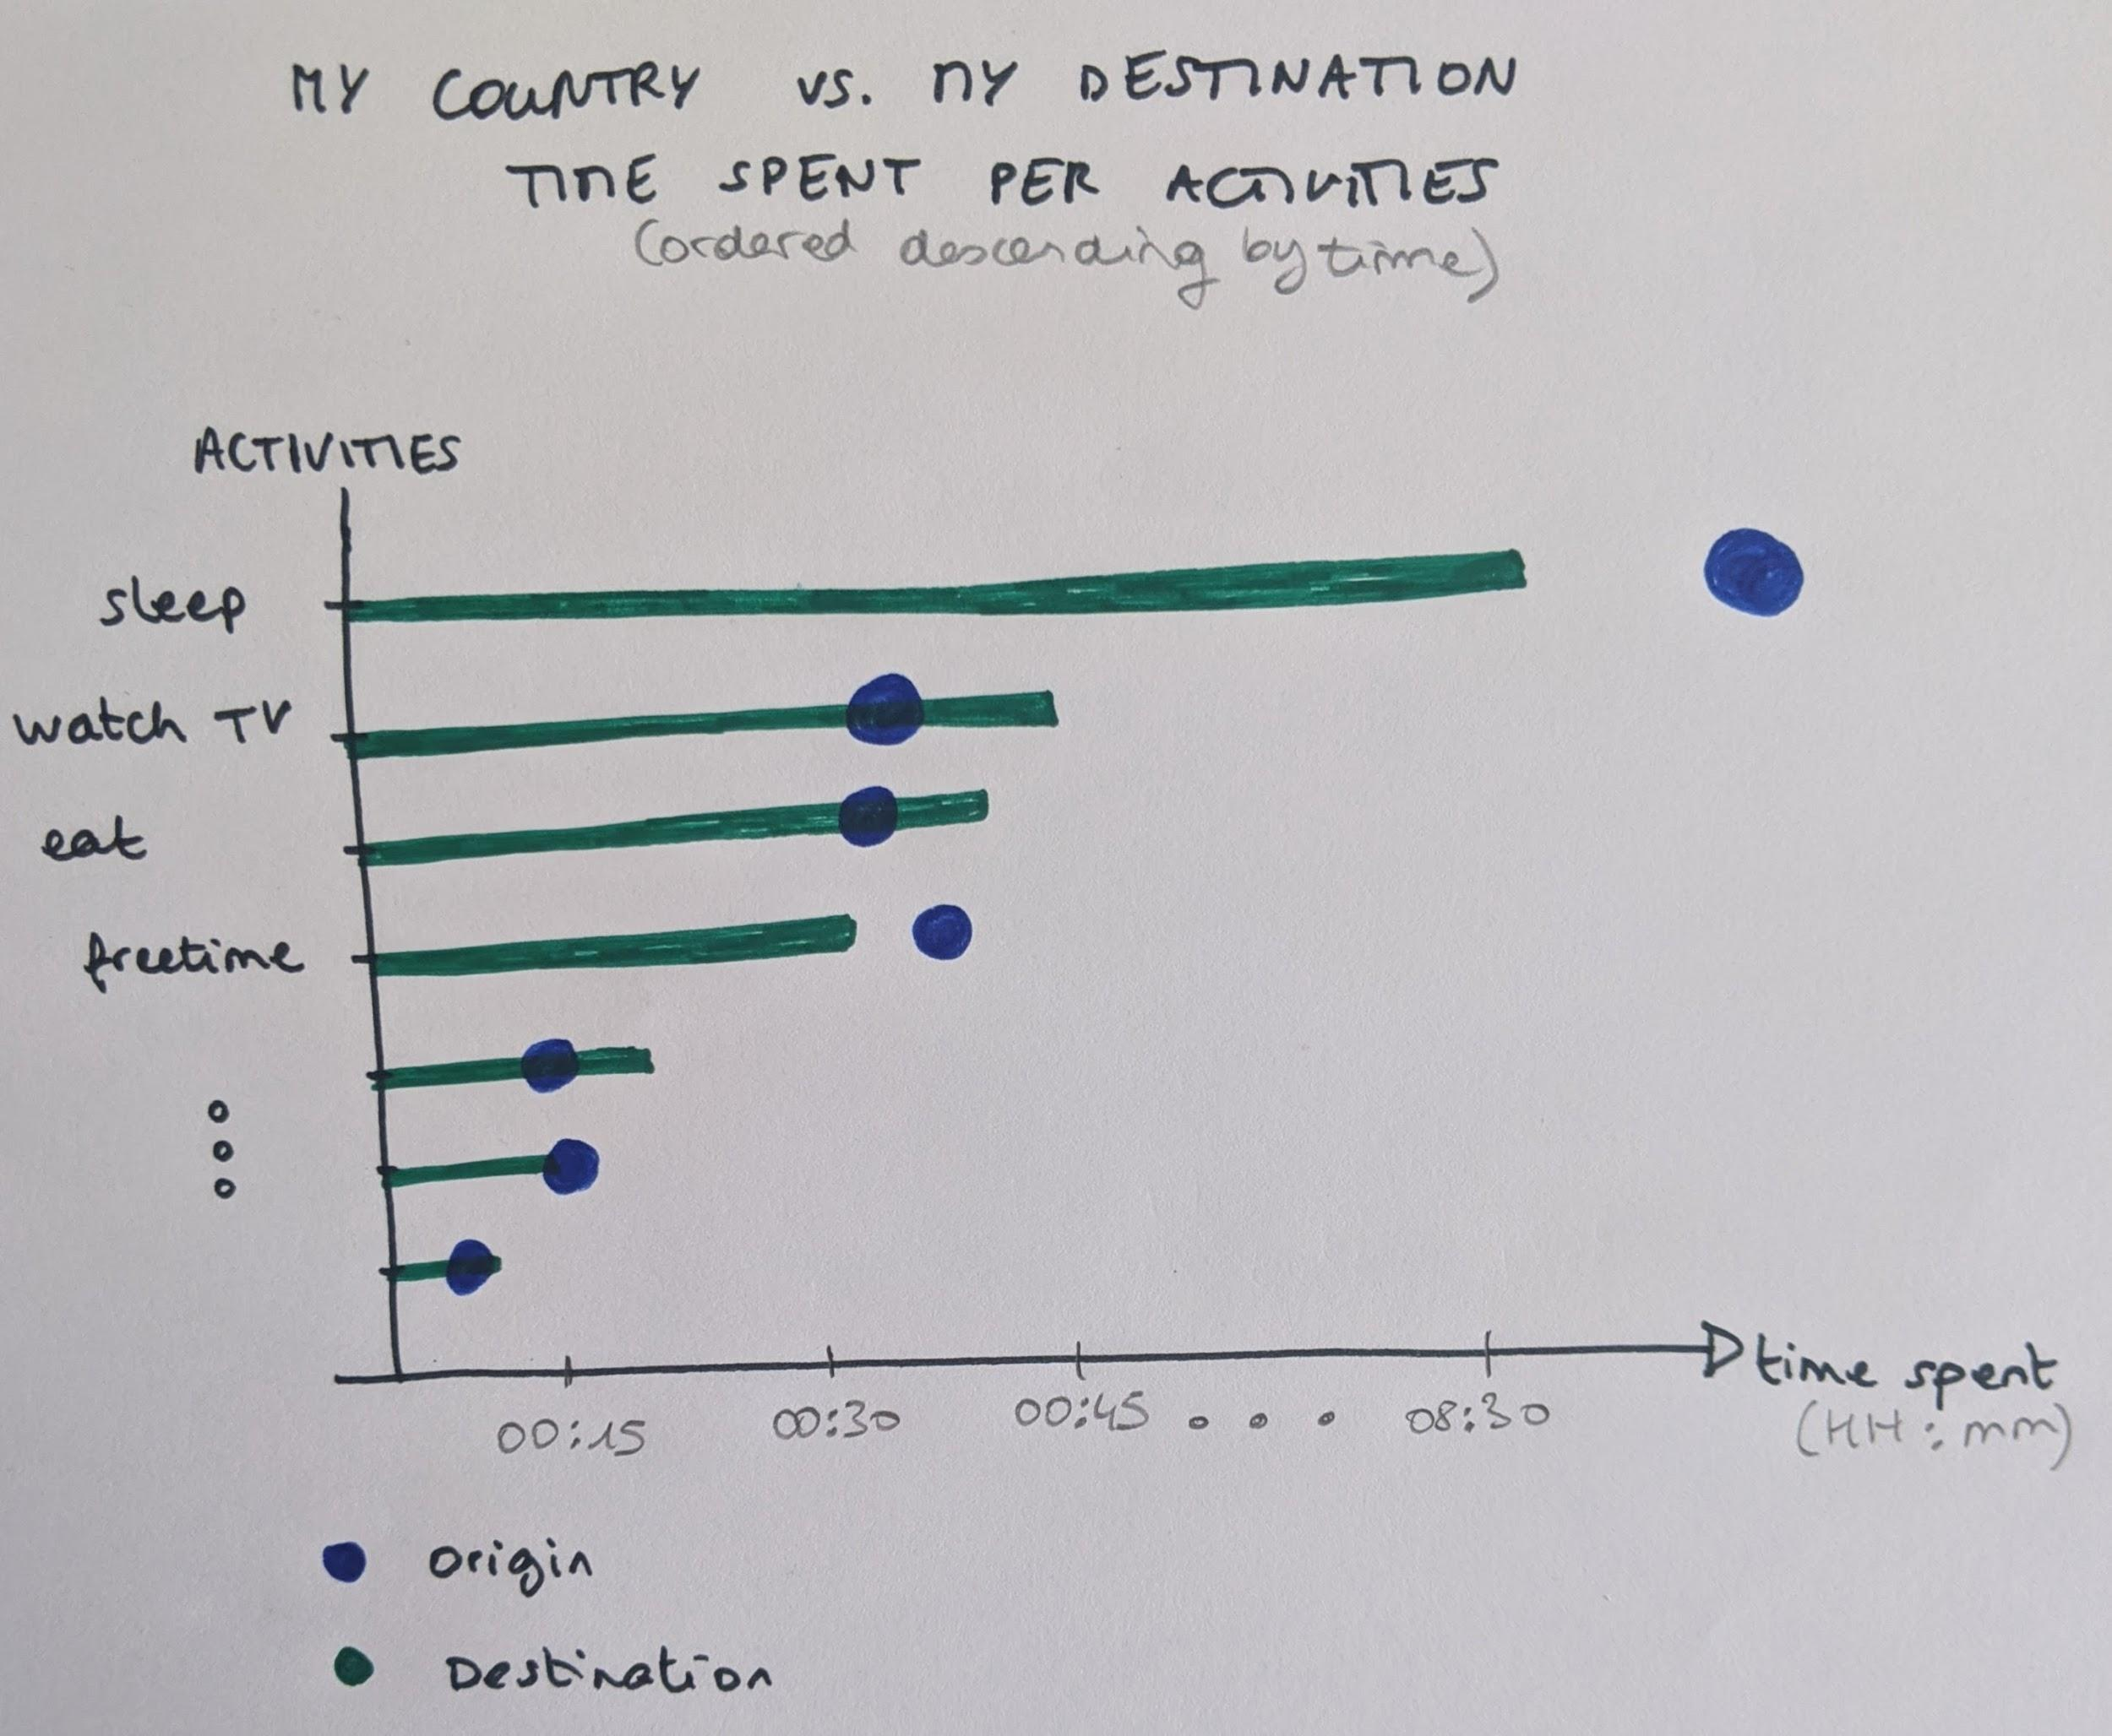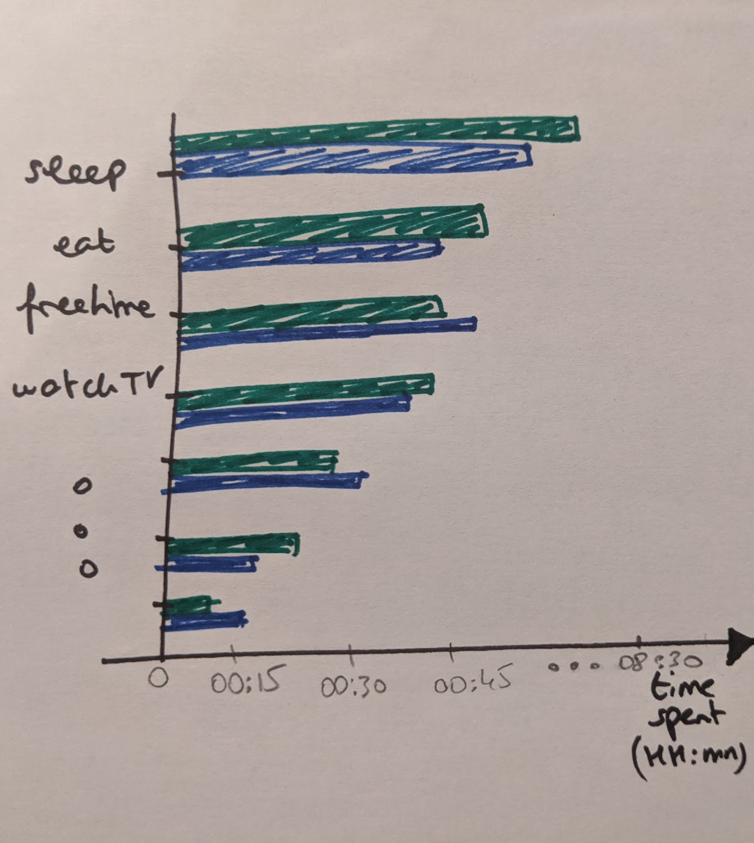

These views are based on the 1st data file.

The first proposition idea is an actual representation of values of times spent for each activity, and allows the user to directly identify which activity takes the most time in the destination country. The time spent for the same activity of the country of origin is also represented.

By default, the 10 most time consuming activities are displayed (time spent in the destination country). Activities are sorted in order of time spent (descending).

An horizontal bar chart allows easy comparison, with different marks for destination and reference. We can sort it out with most frequent activities on top so as not to bother about rare things.

We have chosen to represent the values of the destination as a bar and the origin as points, which allows the reader to easily see the difference between the values of the destination and the origin and to have a faster reading experience. An alternative (2nd proposition on the right) would have been to represent the origin values as a bar as well, which provides the same information as the points. However, we considered that this alternative added complexity to the view, as it would add a dimension (origin/destination) on the vertical axis.

We choose to have both values (origin and destination) displayed on the same diagram rather than two next to each other, to ease the *comparison* for each individual activity.

*3rd idea : focus on schedule*

MY COUNTRY vs. MY DESTINATION

MAIN ACTIVITIES IN 24H

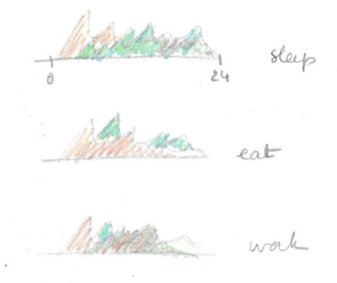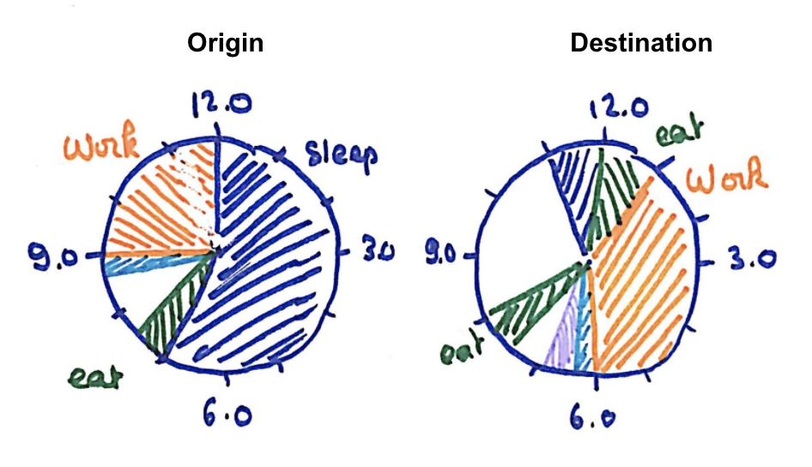

These views are based on the 2nd data file.

These propositions focus on the time schedule of main activities, and allows the user to compare at what time people from the destination and the origin countries do main activities, such as sleeping or eating. It allows the user to know more about habits and compare schedules, and not only time spent.

For the 1st proposition, the 24-hour time range allows the user to fully and easily see when an activity is done.

We choose to have both values (origin and destination) displayed on the same diagram rather than two next to each other, to ease the *comparison* for each individual activity.

Stacked area has the advantage of the overview over the day. It can be harder to read when too many countries are displayed simultaneously, but as only 2 countries are displayed at the same time for one activity, the representation is appropriate.

The 2nd proposition is a nice representation of time, as a clock, , but makes the comparison harder to read.

*Interactions et filtering :*

The 3 ideas seem interesting to show in our final design, as they do not compare 2 countries in the same manner, and bring different level of information to the user. We finally decided to use the following visualisations, and make them interact as the following :

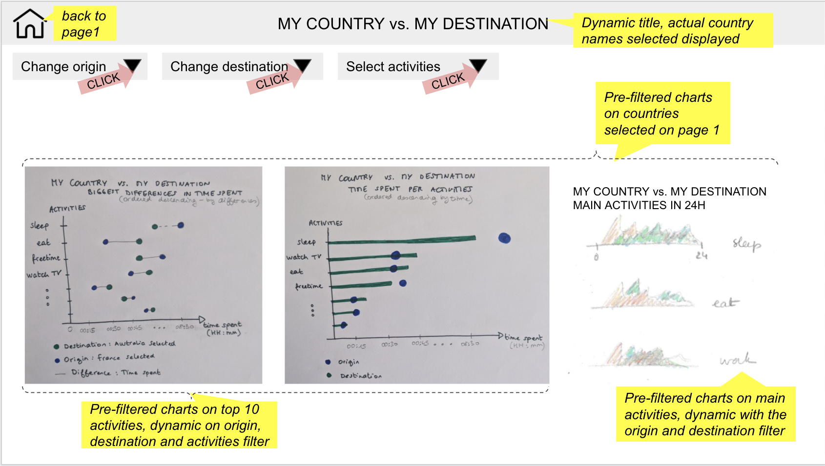

*Illustration of views and interaction between them*

These visualisations are interactive and dynamic : they are pre filtered on the origin and destination countries selected on page 1. It is also possible to change these selected countries via drop down menus.

Also, the first 2 views are sorted by difference size and time spent, respectively. But the user will also be able to select one or several specific activities via a drop down menu, which will update the views and change the top 10 display.

The 3rd view won’t be dynamic with the activity drop down menu, but only with the countries filters. It will display the schedule of main activities, on a 24-hour time range.

# 

# Final design

We choose to combine the previous ideas into 3 different views, each with a clear focus.

**Proposition**: For our final design, we choose to combine the previous ideas into a dashboard with 3 different tabs, each with a clear focus.

For the 2nd and 3rd tabs, we choose to keep different views, summary for presenting and interaction for exploring.

* the starting tab is a **map of Europe** as in design #1, and to fit even better with the Schneiderman’s mantra, we keep it lean with a single activity at time (no gender distinction in this view as opposed to design #1). Selecting one country by clicking on it goes to the next page :
* the second tab represents the **country identity card,** which picks up several ideas from the design #2 :
  + two summary views (fixed activities list):
    - a summary pie chart (simpler version of the donut of fig. 2a, i.e. without the country shape as it had already been selected in the Europe map) with all activities
    - a summary daily schedule (as in fig.2g, with the 7 categories)
  + two exploration views (displaying a selection of activities):
    - top activities bubble view (as in fig.2b)
    - a comparison of top activities of men vs. women, with the same activities as the bubble view (fig.2d). We preferred a dedicated view over a simple filtering for gender selection.
* the 3rd tab is the **my country vs. my destination card** with several ideas from design #3n, where the emphasis is on one to one comparison :
  + one summary view (fixed activities list):
    - small multiples with the daily schedule comparison (as in fig.10, with 7 main activities)
  + two exploration views (displaying a selection of activities):
    - top activities bar chart (as in fig.9 viz2)
    - top differences lollipop chart (as in fig..9 viz1)

“Top activities” in the different views are by default the 10 activities where most time is spent in. The user has access to a drop down list where s/he can check or uncheck activities to filter and/or explore further, for the activities that s.he is most interested in.

**Dashboard model**

NB : The following illustrations allow us to to illustrate the interactions between the different visualisations we have chosen. This is not the final display, in terms of positioning and coloring for example.

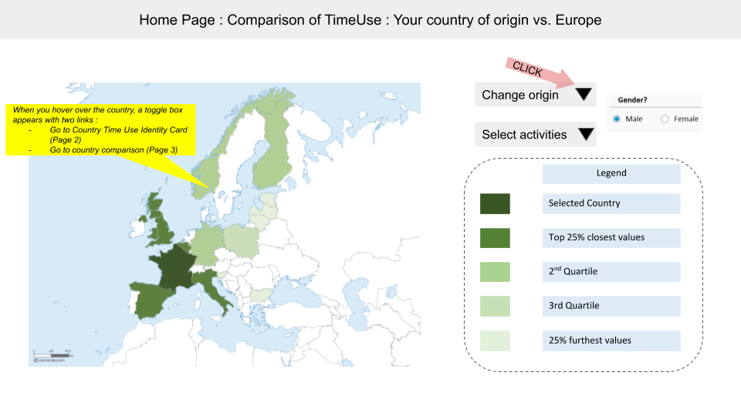

*1st tab illustration*

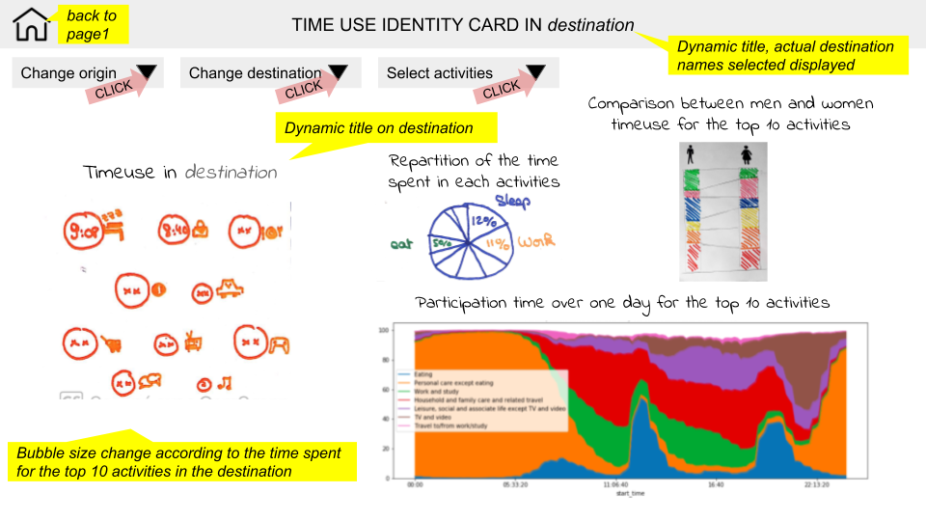

*2nd tab illustration*

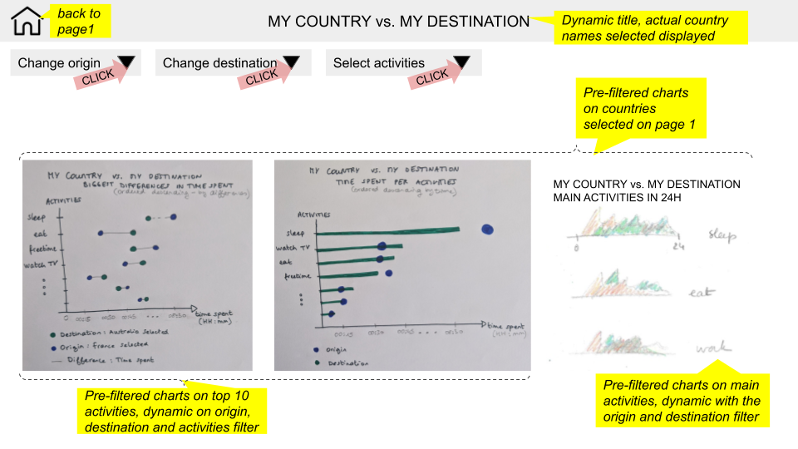

*3rd tab illustration*